Dear (XXX)

I have been informed that the Quadrivalent FluMist will be given in the school on (XXX)
I do not give my permission for (XXX) to have this vaccine due to many reasons, but mainly due to the poisonous ingredients including MSG which opens up the blood brain barrier. https://www.medicines.org.uk/emc/product/3296/pil#gref

There are also a lot of discrepancies in the ‘information’ leaflet given to the parents - please see facts and sources below:

According to the vaccine insert (which can be seen here - https://www.fda.gov/downloads/BiologicsBloodVaccines/Vaccines/ApprovedProducts/UCM294307.pdf )

The FluMist is a live vaccine which can shed for a matter of weeks afterwards but predominantly in days 1-3 (please see excerpts below)

12.1 - FluMist and FluMist Quadrivalent contain live attenuated influenza viruses that must infect and replicate in cells lining the nasopharynx of the recipient to induce immunity. Vaccine viruses capable of infection and replication can be cultured from nasal secretions obtained from vaccine recipients (shedding) [see Pharmacodynamics (12.2)].

12.2 - Shedding Studies Shedding of vaccine viruses within 28 days of vaccination with FluMist was evaluated in (1) multi-center study MI-CP129 which enrolled healthy individuals 6 through 59 months of age (N = 200); and (2) multicenter study FM026 which enrolled healthy individuals 5 through 49 years of age (N = 344). In each study, nasal secretions were obtained daily for the first 7 days and every other day through either Day 25 and on Day 28 or through Day 28. In study MI-CP129, individuals with a positive shedding sample at Day 25 or Day 28 were to have additional shedding samples collected every 7 days until culture negative on 2 consecutive samples.

The highest proportion of subjects in each group shed one or more vaccine strains on Days 2-3 post vaccination. After Day 11 among individuals 2 through 49 years of age (n = 443), virus titers did not exceed 1.5 log10 TCID50/mL.

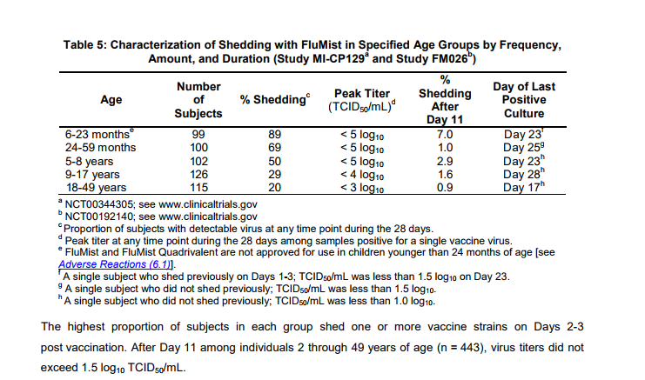

"Virus shedding was evaluated for 21 days by culture of nasal swab specimens. Wild-type A (A/H3N2) influenza virus was documented to have circulated in the community and in the study population during the trial, whereas Type A (A/H1N1) and Type B strains did not."

It is possible for those vaccinated with the spray to spread flu, particularly amongst immune compromised people. Quoted from source: https://www.medicines.org.uk/emc/product/3296/smpc
Vaccine recipients should be informed that Fluenz Tetra is an attenuated live virus vaccine and has the potential for transmission to immunocompromised contacts. Vaccine recipients should attempt to avoid, whenever possible, close association with severely immunocompromised individuals (e.g. bone marrow transplant recipients requiring isolation) for 1-2 weeks following vaccination. Peak incidence of vaccine virus recovery occurred 2-3 days post-vaccination in Fluenz clinical studies. In circumstances where contact with severely immunocompromised individuals is unavoidable, the potential risk of transmission of the influenza vaccine virus should be weighed against the risk of acquiring and transmitting wild-type influenza virus.

As you can see, there is sufficient evidence to support the fact that the vaccine does shed quite predominantly. Due to this, I do not want (XXX) to be in direct contact with anyone receiving the flu mist for the remaining of that week as it could put us all at risk; so we will be keeping them home on (XXXXXXX) dates.

I would appreciate it if this could be noted as authorised absence due to nature of having to keep them off. If their teachers would like to send home any work for them to do, we are more than happy to oblige and we shall be doing our own home educating on those days.

I look forward to hearing from you.

Kind regards

